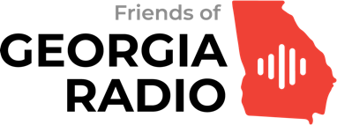

2023 Innovative Georgia Radio Station of the Year Nomination Form

Nominations for 2023’s Innovative Georgia Radio Station of the Year are open from May 8 — July 15, 2023. Friends of Georgia Radio members may submit one nomination. Please fill out this form, attach background information you feel is relevant (and provide a download link for large files). Please email it to admin@friendsofgeorgiaradio.org.

Your Name:
You must be a current member to nominate a station. You can join here.

Your relationship to the station: (under our guidelines, you can work at or have an ownership stake in the station):

Your phone number and email address, in case we need to reach you:

Call letters and market of the station you are nominating:
The web address of the station:
Name and phone number of a station contact, if not yourself:

Please attach a document that outlines the station’s accomplishments over the past year.

The board of Friends of Georgia Radio is focusing on Georgia-licensed radio stations that are successfully innovating in how they:

• Find, hire, and retain talent
• Utilize streaming, the web, and social media technology
• Generate revenue
• And, above all, engage with the community

You may include links to access or download photos, videos, airchecks, and information from community outlets and trade publications. Please do not provide us with confidential information.

Honorees will be announced on July 24, 2023, and presented with their Crystal Mic Awards during the Friends of Georgia Radio Gala on August 26, 2023.

